Name:  Class: | ____________________________________  ________________ |  | Date: __________
 | Year 7 Mathematics  Investigation 3, 2018  Topic – Equations |  | / 24  %
Total Time: | 45 min
Weighting: | 11 %
Equipment: | Page of notes and calculator

The Problem
Farmer Sue has a paddock to which she brings her cows for milking. Next to the paddock there is a large field with free range chickens. Every now and then chickens escape into the cow paddock. Farmer Sue needs your help…

Question 1 [4 marks]
Farmer Sue found 4 chickens and 8 cows in the paddock and had to race around to catch all the chickens and return them to their own yard.

- How many heads would she have counted?

12
- How many legs would she have counted?
40

- If there were 8 chickens and 4 cows how many would she have counted:
- Heads? 12

- Legs? 32

Question 2 [8 marks]
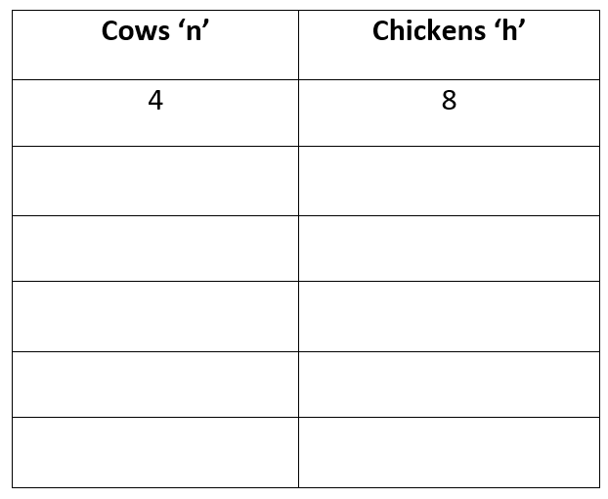
If n represents the number of cows and h represents the number of chickens that have escaped the paddock.

- Write an equation that shows 12 heads together.
N + h = 12

- What are the possible combinations of cows and chickens that would give a total of 12 heads?
- Any numbers will do as long as they add to 12

- Write an equation to show 40 legs together.
4n + 2h = 40

- Substitute n = 8 and h = 4 into your equation to make a true statement.
(4 x 8) + (2 x 4) = 40

Question 3 [2 marks]
If farmer Sue counted 40 heads, choose two possible values for the number of cows and chickens she might own.

N = 10 and h =30 or n = 15 and h =25

Question 4 [2 marks]
For each choice, using an appropriate equation, calculate the number of legs she would have counted?
4n + 2h =
(4 x 10) + (2 x 30) = 100

4n + 2h =
(4 x15) + (2 x25) =110

Question 5 [3 marks]
Can you find out the values for n and h that would give 40 heads and 112 legs?
N + h = 40

4n + 2h = 112

16 cows and 24 chickens

Question 6 [2 marks]
If the number of heads stays the same but the number of legs changes explain how the numbers of each animal in the paddock change.

Cows have 4 legs and chickens only have 2. If the number of cows decrease by x the number of chickens will increase correspondingly. There will be 4x less cow legs and 2x more chicken legs. This means there will be -2x legs overall.

Extension [3 marks]
Deep in the ocean, a scuba diver discovers a collection of 21 crabs and octopuses together in the same small area. He counts 198 legs altogether. (A crab has 10 legs and an octopus had 8.) How many crabs and octopuses were there?
A =number of crabs
B = number of octopus
A + b = 21
10a + 8b = 198
6 octopus and 15 crabs.

